1/ ECG_108

|  |  |  |  |  |
| --- | --- | --- | --- | --- |
| Algorithm | Data | Param | Anomalies | Time |
| VL with Qudratic 2 | (0-17500) | e1 = 5, e2 = 0.3, k =1, alpha = 3.5, delta = 10 | (10875 - 11010) | 00:0:10 |
| VL with Extrem Points 2 | (0-17500) | R=1.04,MinLength = 50, k = 1, alpha = 4, delta = 10 | (10792-11380)(10017-10518) | 00:00:47 |
| HotSax | (0-17500) | Length = 135, PAA Length = 27/588,84 | 10853/10869 | 00:06:00/00:07:17 |

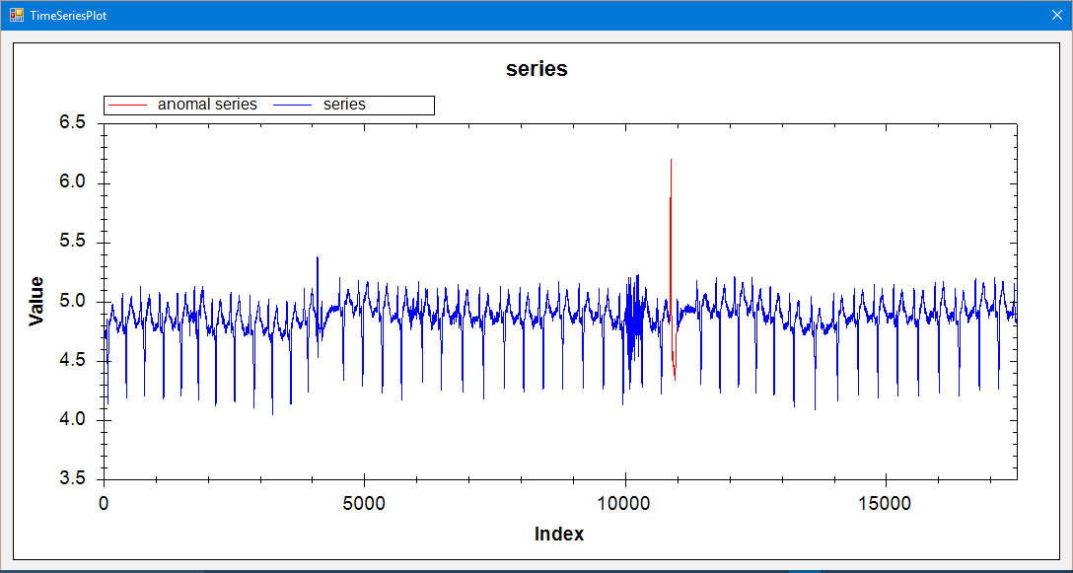 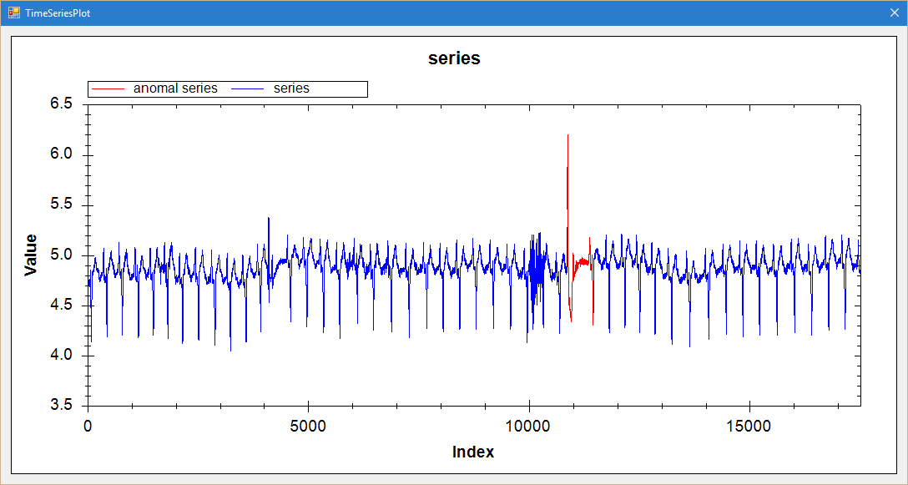

2/ ECG 308

|  |  |  |  |  |
| --- | --- | --- | --- | --- |
| Algorithm | Data | Param | Anomalies | Time |
| VL with Qudratic 2 | (0-1300) | e1 = 51000, e2 = 50, k =1, alpha = 2.2, r =10 | (656-691) | 00:00:00.31 |
| VL with Extrem Points 2 | (0-1300) | R=1.03,MinLength = 10, k = 1, alpha = 2.5, delta=25 | (673-735) | 00:00:02 |
| HotSax | (0-1300) | Length = 35, PAA Length = 5/62,9 | 681/673 | 00:00:01/00:00:10 |

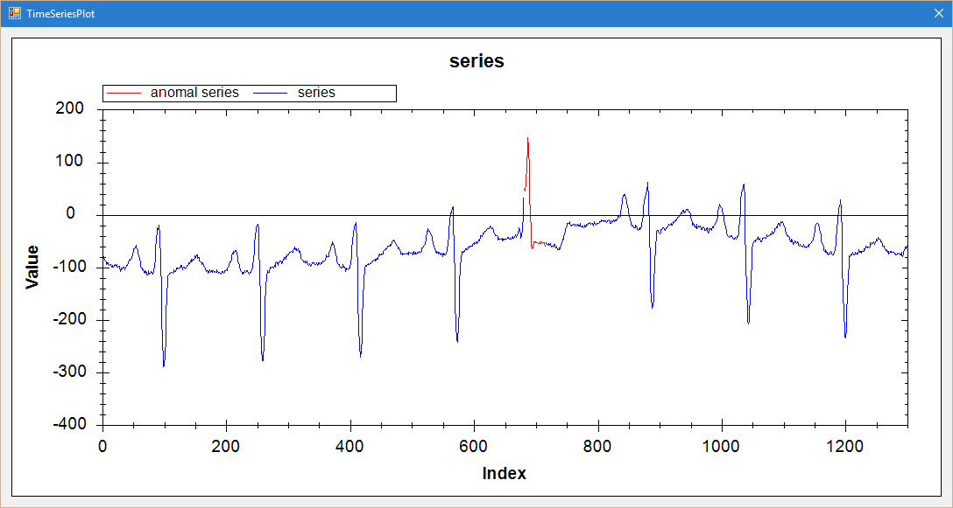

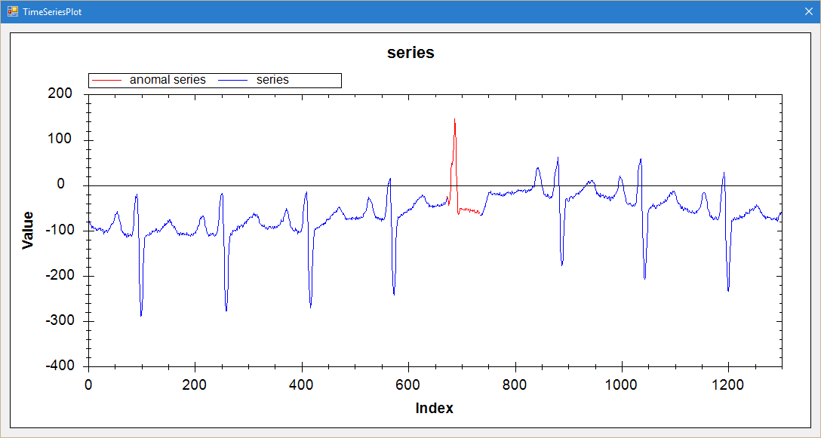

3/ Memory

|  |  |  |  |  |
| --- | --- | --- | --- | --- |
| Algorithm | Data | Param | Anomalies | Time |
| VL with Qudratic 2 | (0-6875) | e1 = 8, e2 = 0.1, k =1, alpha = 2.2, r=10 | (2425-2590)(6425-6469) | 00:00:04 |
| VL with Extrem Points 2 | (0-6875) | R=1.1,MinLength = 10, k = 1, alpha = 2.8, r=10  (ml = 40, r = 10) | (2399-2903) | 00:00:06 |
| HotSax | (0-6875) | Length = 165, PAA Length = 33/504,100 | 2427/2346 | 00:01:18/00:01:40 |

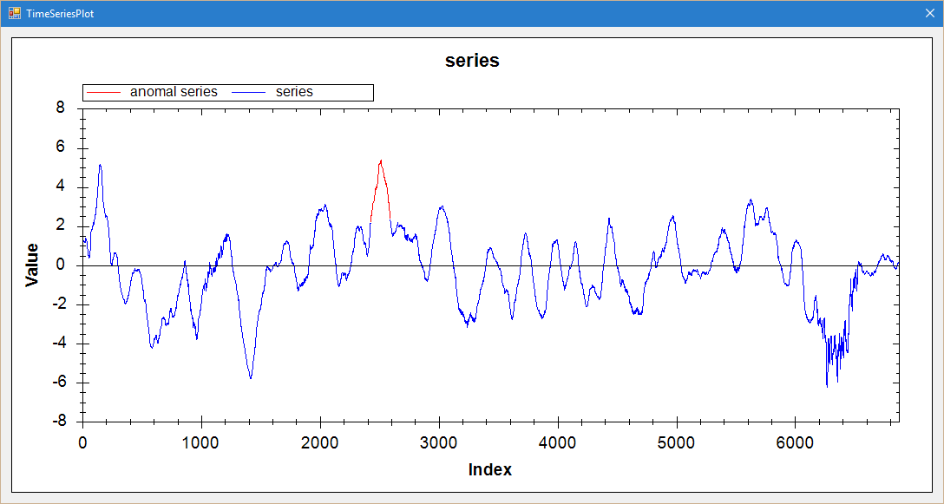

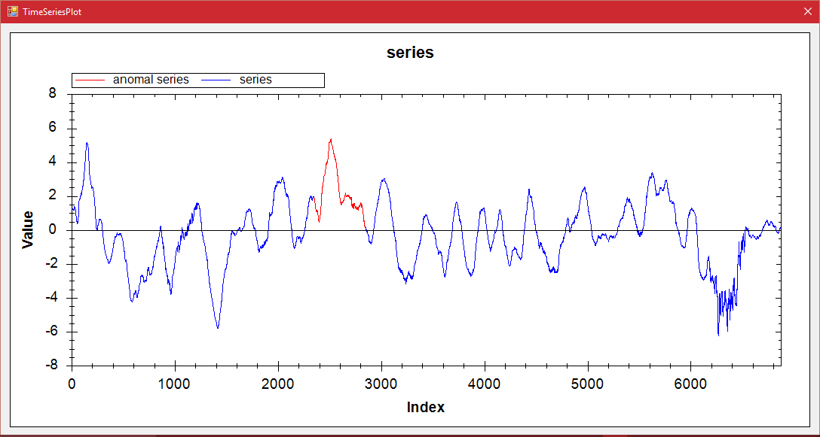

4/ Power demand Italia

|  |  |  |  |  |
| --- | --- | --- | --- | --- |
| Algorithm | Data | Param | Anomalies | Time |
| VL with Qudratic 2 | (0-7000) | e1 = 100000, e2 = 100, k =1, alpha = 2.5, r = 10 | (5331-5663) | 00:00:09 |
| VL with Extrem Points 2 | (0-7000) | R=1.8,MinLength = 20, k = 1, alpha = 3, r=10 | (5383-5719) | 00:00:11 |
| HotSax | (0-7000) | Length = 332, PAA Length =41/336,40 | 5320/5318 | 00:01:55/00:01:51 |

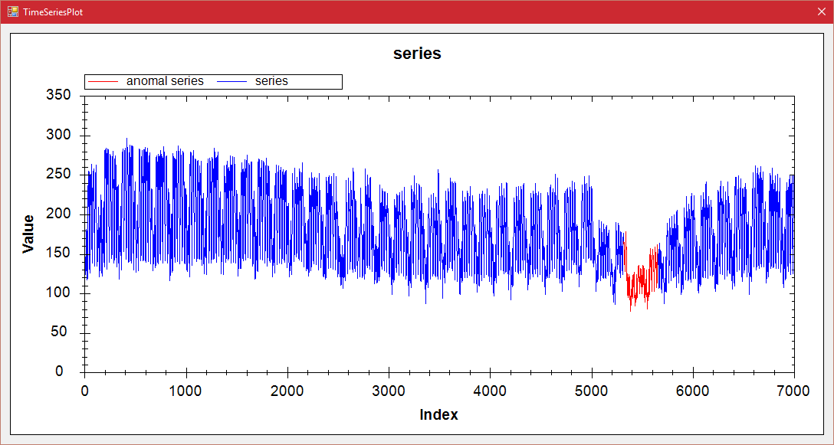

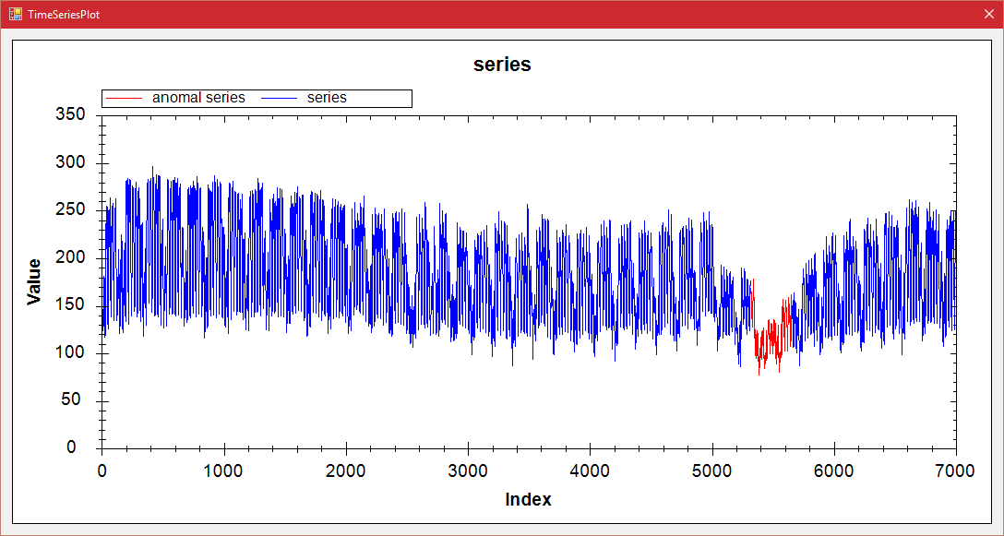

5/ Power Demand Dustch

|  |  |  |  |  |
| --- | --- | --- | --- | --- |
| Algorithm | Data | Param | Anomalies | Time |
| VL with Qudratic 2 | (0-15000)/(5000-14000) | e1 = 35000000/31000000, e2 = 500, k =1, alpha = 1.9/1.6, r =25/20 | (6424-7709)(3109-3815) | 00:00:01 |
| VL with Extrem Points 2 | (5000-14000) | R=1.7,MinLength = 180, k = 1, alpha = 1.33, r=25 | (6277-7544) | 00:00:09 |
| HotSax | (0-15000)/(5000-14000) | Length = 1285, PAA Length = 257/1267,158 | 6384/6402 | 00:04:03/00:03:44 |

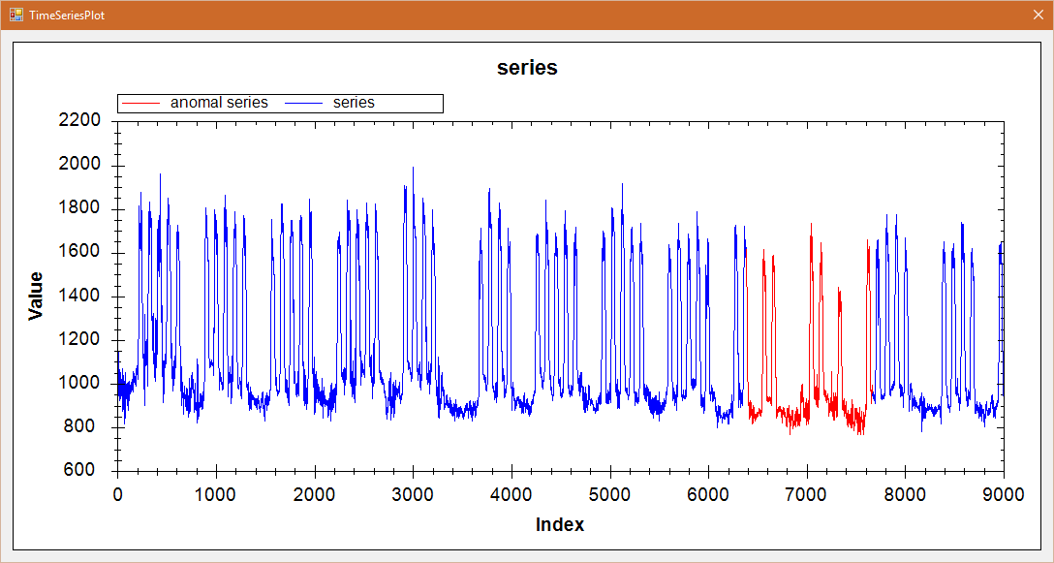

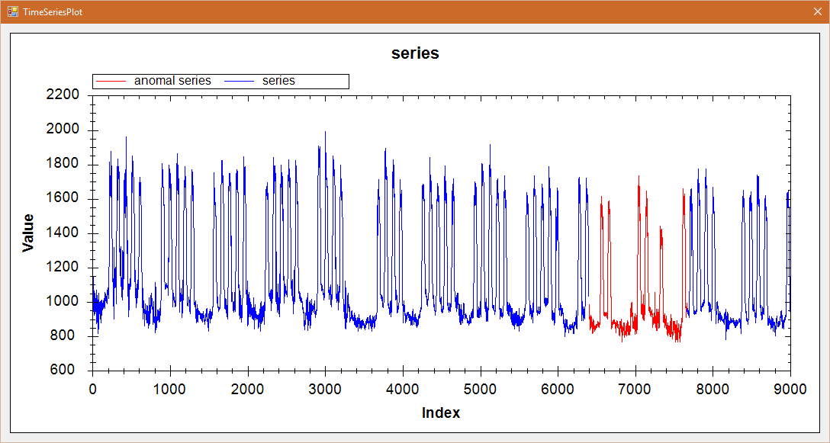

6/ ERP

|  |  |  |  |  |
| --- | --- | --- | --- | --- |
| Algorithm | Data | Param | Anomalies | Time |
| VL with Qudratic 2 | (0-5000) | e1 = 3, e2 = 1.0, k =1, alpha = 3.0, r =15 | (2617-2686) | 00:00:07 |
| VL with Extrem Points 2 | (0-5000) | R=1.42,MinLength = 10, k = 1, alpha = 3.5, r =10 | (2602-2751) | 00:00:14 |
| HotSax | (0-5000) | Length = 69, PAA Length = 9/149,18 | 2606/2539 | 00:00:52/00:00:55 |

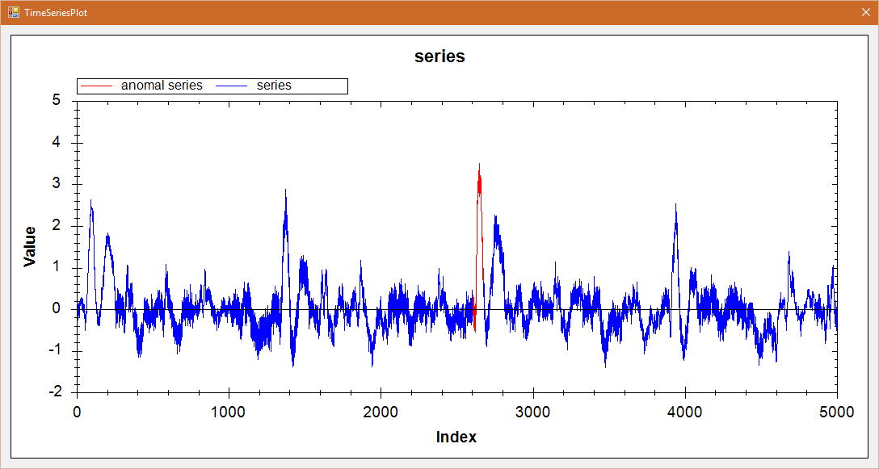

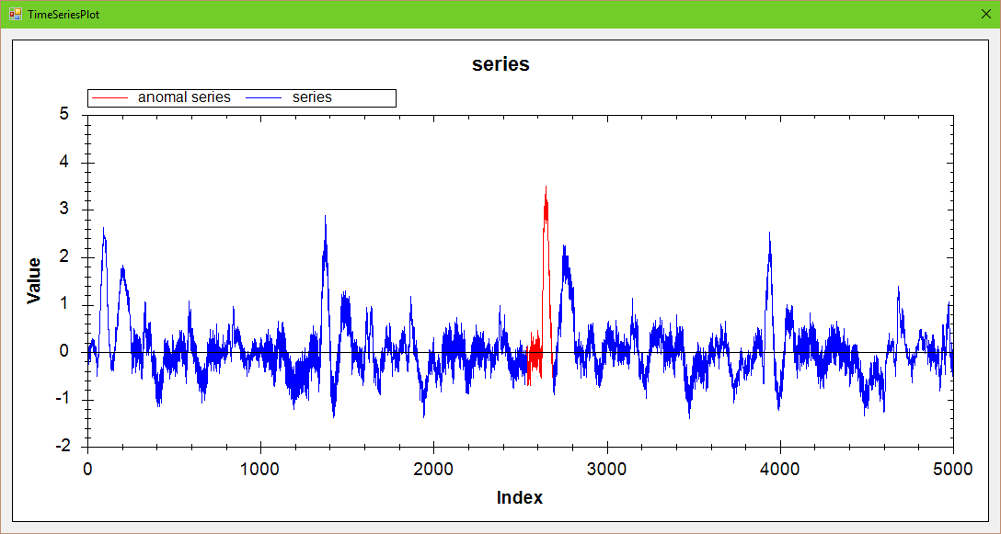

7/ Stock_20

|  |  |  |  |  |
| --- | --- | --- | --- | --- |
| Algorithm | Data | Param | Anomalies | Time |
| VL with Qudratic 2 | (0-5000) | e1 = 2, e2 = 0.1, k =1, alpha = 3.5, r =10 | (2961-3667) | 00:00:01 |
| VL with Extrem Points 2 | (0-5000) | R=1.01,MinLength = 200, k = 1, alpha = 1.5, r = 10 | (2960-3809) | 00:00:01 |
| HotSax | (0-5000) | Length = 706, PAA Length = 100/849,121 | 2955/2888 | 00:01:30/00:01:19 |

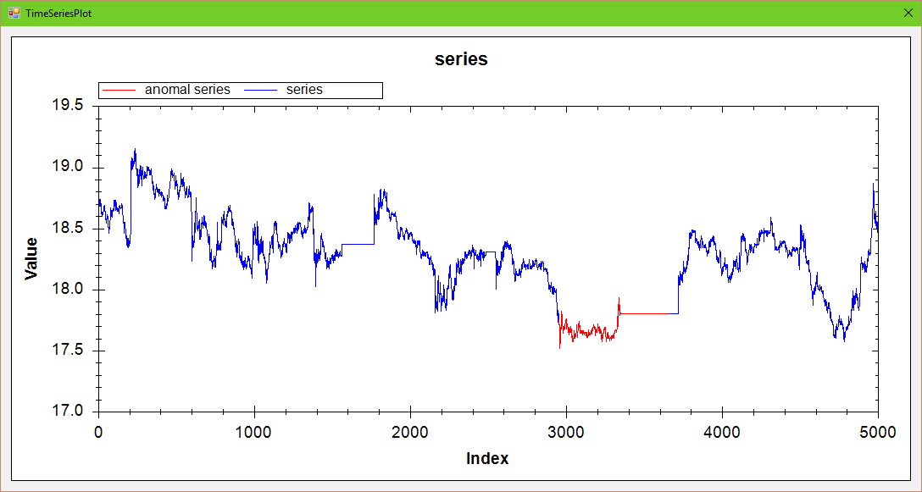

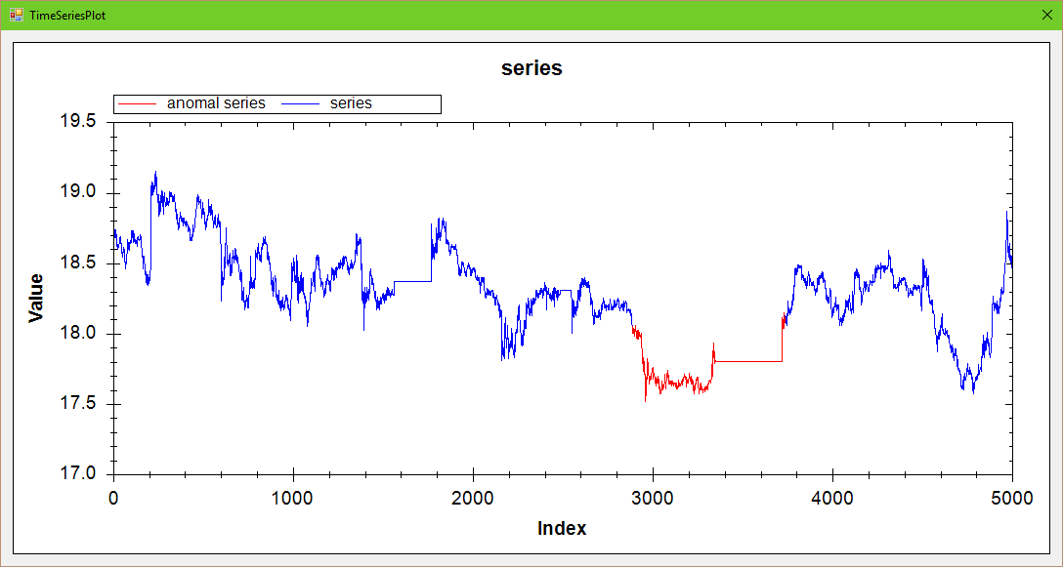

8/ TEK16

|  |  |  |  |  |
| --- | --- | --- | --- | --- |
| Algorithm | Data | Param | Anomalies | Time |
| VL with Qudratic 2 | (0-5000) | e1 = 14.5, e2 = 0.1, k =1, alpha = 2.0, r =10 | (4262-4398) | 00:00:01 |
| VL with Extrem Points2 | (0-5000) | R=1.02,MinLength = 50, k = 1, alpha = 1.5, r = 10 | (4197-4525) | 00:00:01 |
| HotSax | (0-5000) | Length = 136, PAA Length = 17/328,41 | 4288/4076 | 00:00:47/00:00:49 |

